Ex.No : 7b | Data Visualization Using Tableau-  Sales Data
Date :

Aim :
To connect, analyze, visualize, and create interactive dashboards using Tableau for effective business intelligence and data analytics.
Algorithm :
- Open Tableau Desktop and choose excel file
- Creating Worksheet
- Create a bar chart for revenue by product category
- Create a pie chart for revenue by payment method
- Create a line chart for revenue trend
- Create a KPI for total revenue
- Create a full dashboard for sales dataset
Output :
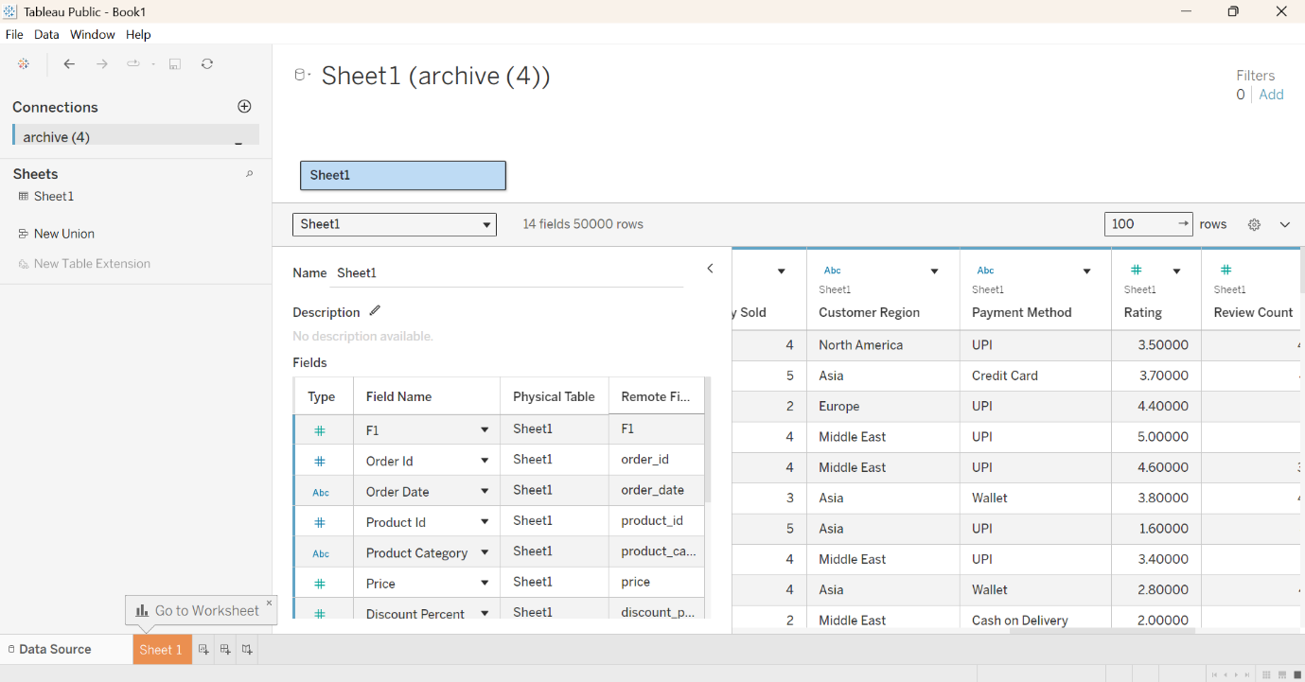

Creating Bar Chart :
Comparison of revenue by product category
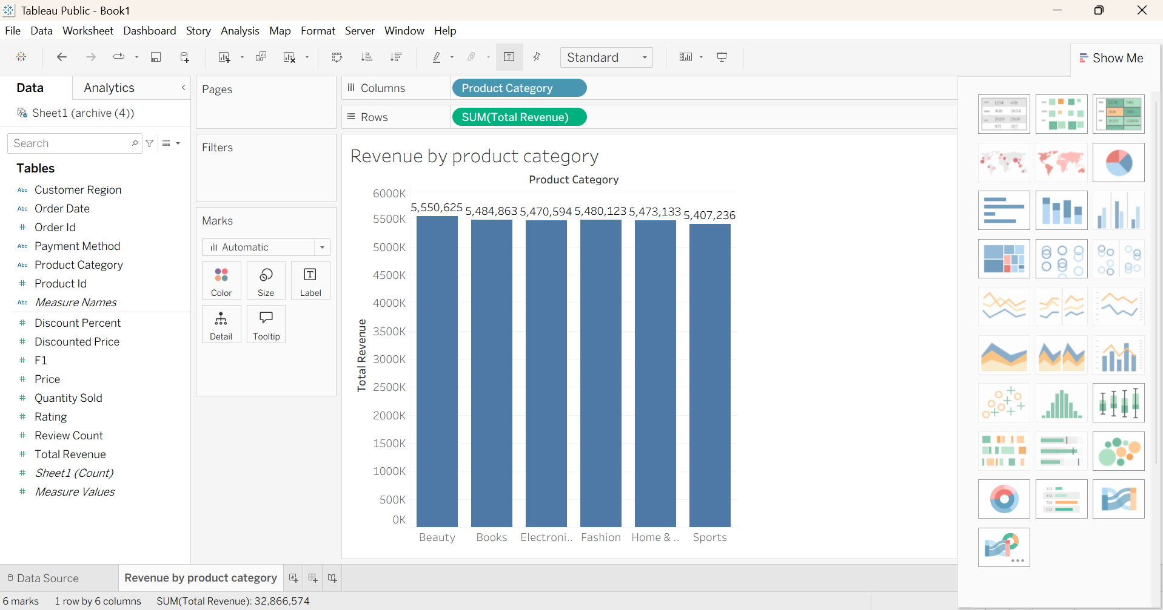

Creating Pie Chart :
Revenue by Payment Method
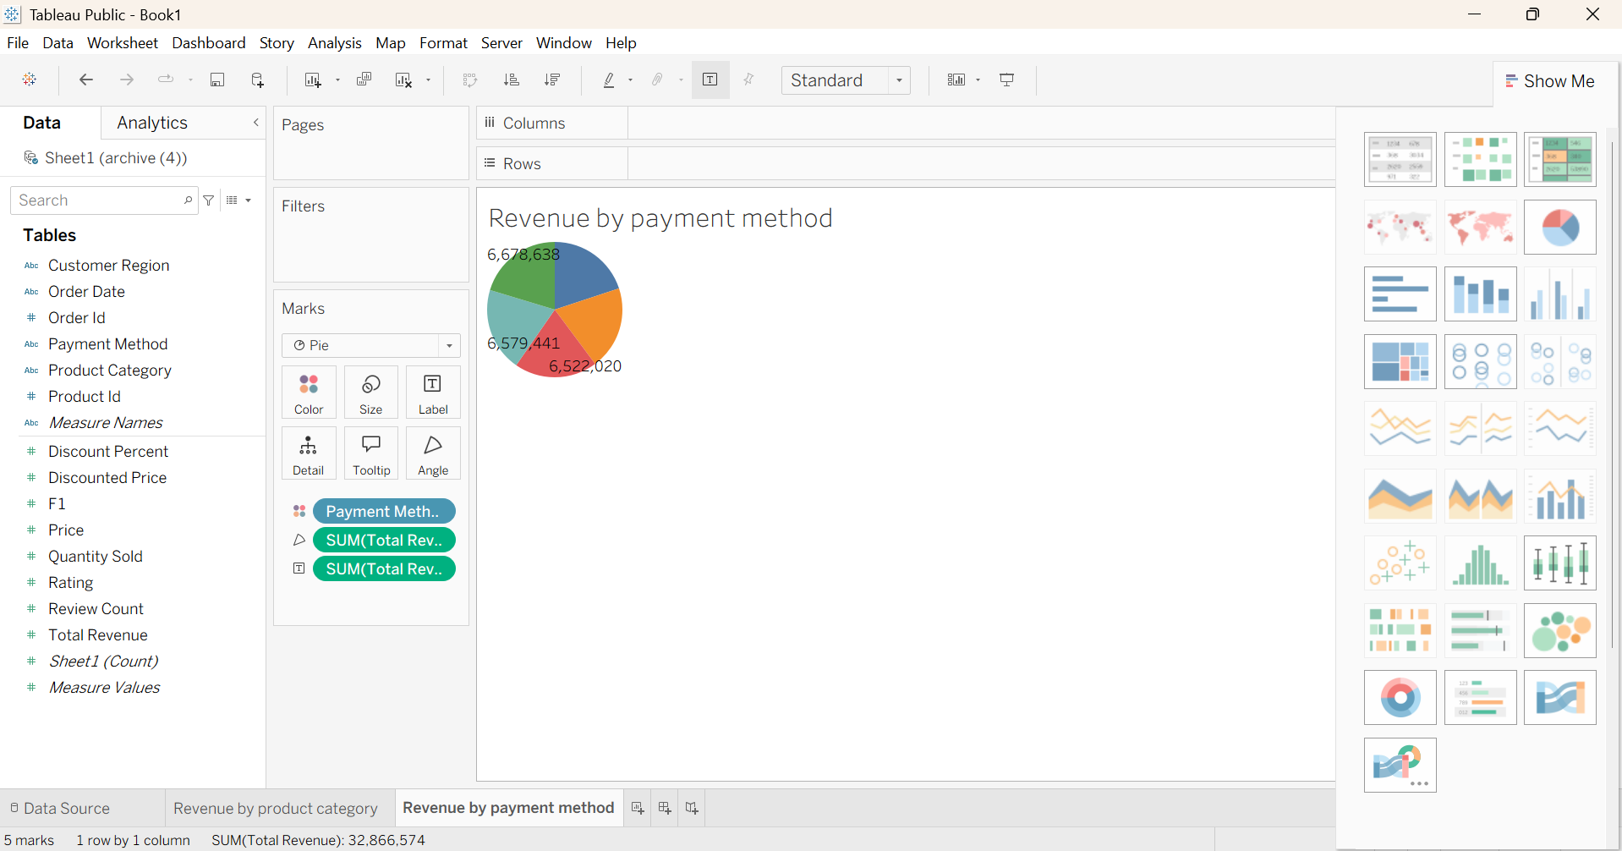
Creating KPI for Total Revenue :

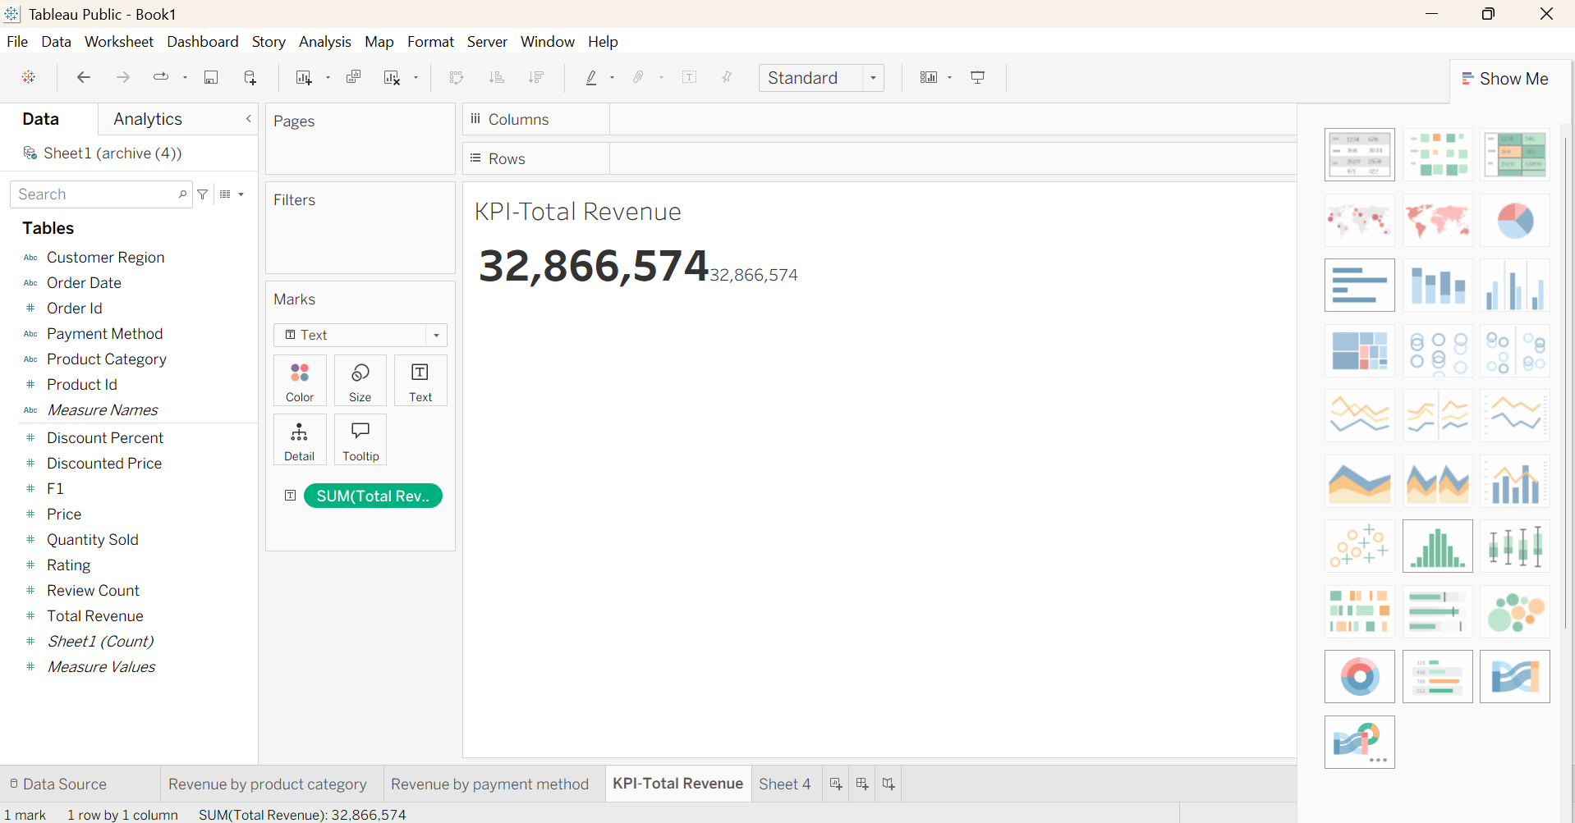

Creating Line Chart for Revenue Trend by Month:

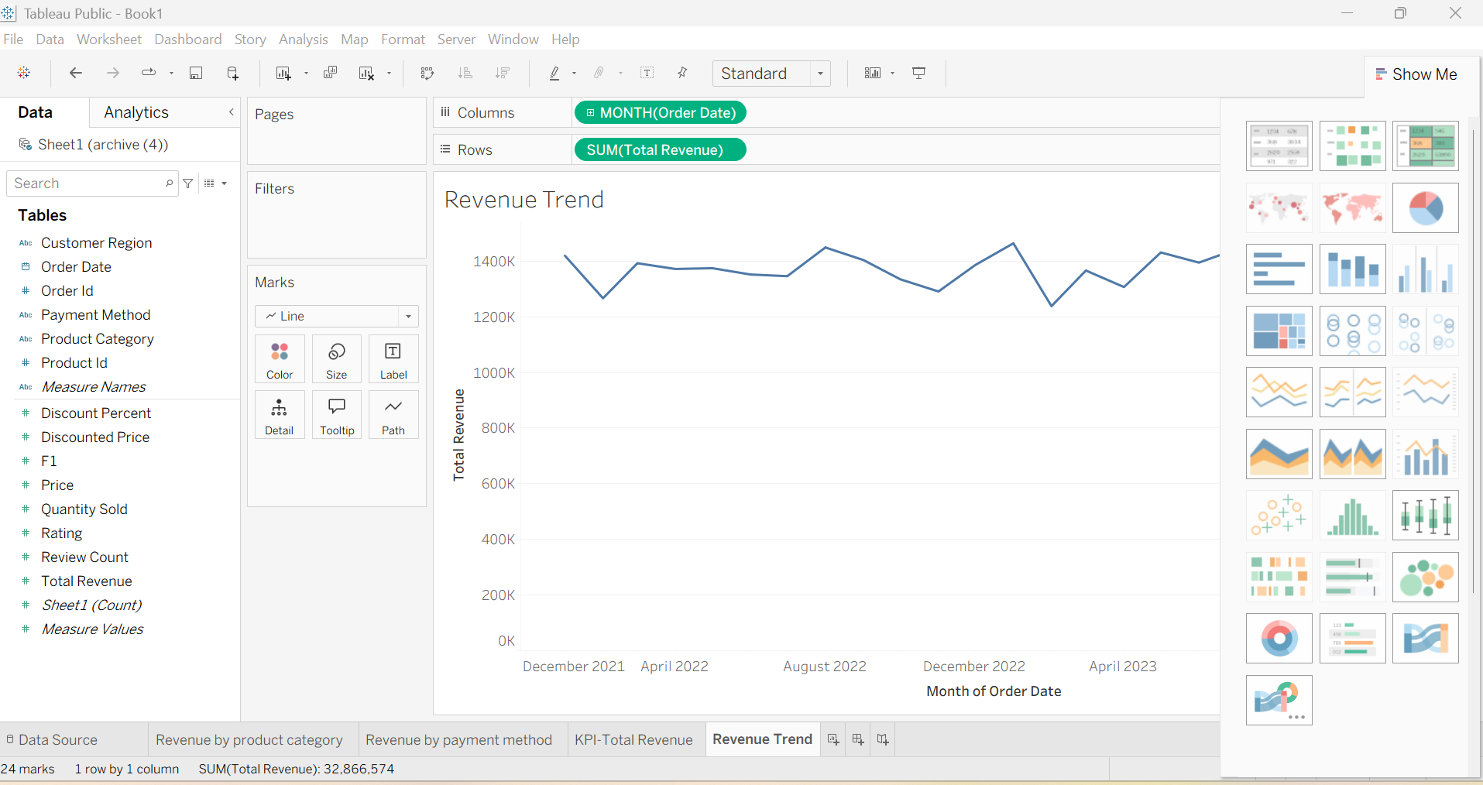

Dashboard:

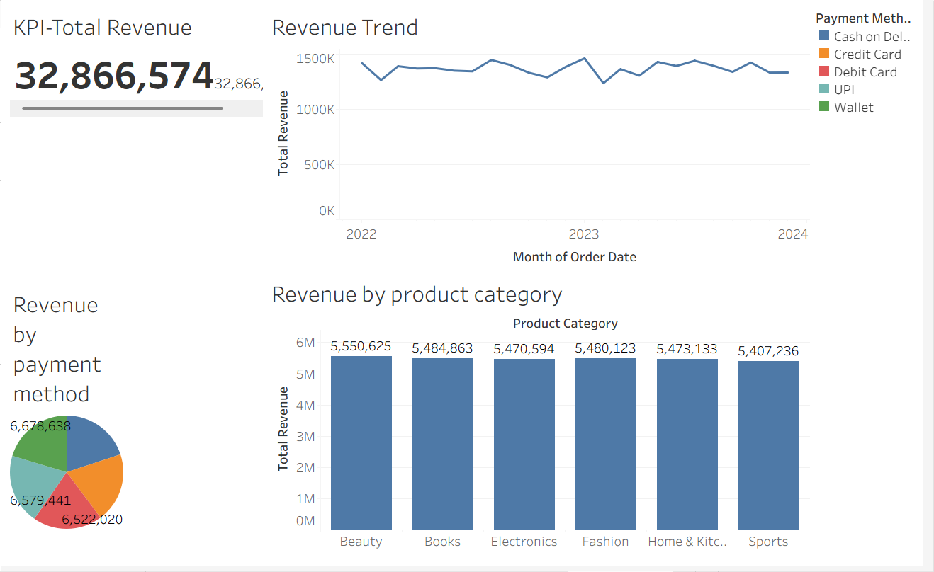

Result :
Thus, Tableau was used successfully to connect datasets, create worksheets, apply filters and parameters, generate visualizations, build dashboards, and create stories for business intelligence and analytical decision-making

